

Year 8

Food – Sept 2024
Recipes

Name ___________________________ Form ________

Teacher__________________________

DT Group ________________________ Day________
11

Please note that the recipes can also be found on the Highfields School Website under: Parents/ Parent Booklets/ Food Recipe Booklets & each week the recipe will be set as homework on Satchel One

Special Dietary Needs

Every year the number of students and their family members with special dietary needs increases. Whether this is due to an allergy or intolerance or for religious or ethical reasons we aim to accommodate your requirements and allow you to enjoy practical food lessons.

Most of the time this will require you to exchange one ingredient for another, i.e. meat for Quorn or cow’s milk for soya milk or wheat flour for a gluten free variety BUT please let your teacher know so that arrangements and alternative recipes can be found, where necessary.
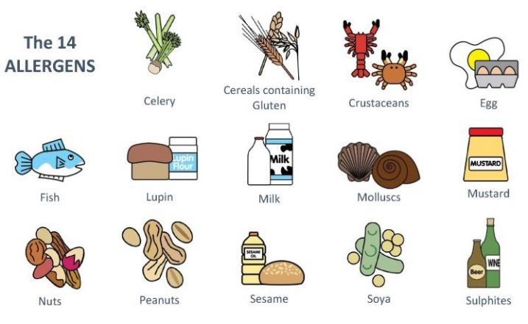

Please note, although Starkholmes is now a nut-free zone, because students provide their own ingredients for practical lessons there can never be a guarantee that these are entirely nut free due to cross contamination either during food processing or at home. It is essential if you have an allergy, that you provide all of your own ingredients and work completely independently using separate equipment. Staff and students must ensure they do not bring in any product containing nuts. Potential allergens above have been highlighted in the recipes in bold/underlined/italic; please ask if you have any concerns.

Cooking at Highfields School
In this booklet are the recipes that you will be making this year during your time in food. You will be able to make some ingredient choices in each dish to enable you to tailor it to your families’ likes and dislikes.

All students are expected to bring in their ingredients for every practical lesson. Food is part of the KS3 National Curriculum. If there are any issues that make this difficult, please speak to your teacher.

Students must have a large-lidded container to carry their ingredients to school and their cooked product(s) home. The container must be named, as in any one day there can be up to 80 students cooking.

Ingredients that require refrigerating should be put into a separate named bag ready to place straight in the fridge upon arrival at school.

Where possible, students should weigh and measure their ingredients at home. This is part of the learning experience and helps to speed up the lesson. However, we do have digital scales at school that can be used.

Ingredients must be brought to their food practical room before morning lesson on the day of their practical lesson. Ingredients that require refrigerating should be put into the correct refrigerator (labelled) and other ingredients should be placed on the shelf.

Finished products and any remaining ingredients must be collected at the end of the school day. No products can be collected before 3.20pm unless the student has informed the teacher beforehand and has a valid reason for doing so e.g. leaving early for a medical appointment.

All boxes should be labelled with the student’s name, form and date.
All equipment will be provided by school; however, we would ask that you provide your child with a clean apron.

Thank you
Mrs Hakin

TOMATO, CHEESE & BASIL TART

Ingredients

Base | Filling
100g Plain flour | 1 Tomato (sliced) or 4-6 Cherry tomatoes can also be used
50g Block Butter /Margarine | 50g Cheese of your choice
2-4 x15ml Cold Water | Handful of Basil Leaves (opt)
 | 2 Eggs
 | 125ml Milk
 | Seasoning (sch)
*Container for taking tart home in/ apron
*Foil dish will be provided by school

Equipment – Weighing scales, sieve, mixing bowl, measuring spoons, palette knife, flour dredger, rolling pin, sandwich tin or foil tray, fork, chopping board, knife, grater, measuring jug, baking tray.
Method
- Preheat the oven to 180°C, gas mark 4.
- Make up the shortcrust pastry: sift the flour into the bowl. Rub the butter or margarine into the flour, using your fingertips, until it resembles breadcrumbs. Add the cold water gradually and start to mix together; mix to form a firm, smooth dough.
- Roll out the pastry, on a lightly floured surface.
- Line the foil dish or sandwich tin with the pastry.
- Trim the edges of the pastry using the palette knife
- Prick the bottom of the pastry with a fork.
- Slice the tomatoes or half the cherry tomatoes.
- Slice or grate the cheese.
- Whisk the eggs and milk together in the measuring jug using the fork. Tear the basil into the mixture, then add a few twists of black pepper.
- Pour the egg mixture into the pastry shell
- Arrange the tomato slices and cheese over the top.
- Place on a baking tray and bake for 30 minutes, until golden and firm.
DRIZZLE CAKE

Ingredients

Cake Mixture | Glaze
100g Self-Raising flour | 1 Orange or Lemon juice
100g Soft margarine | 25g Caster sugar
100g Caster sugar
2 Eggs
Zest of 1 Orange or Lemon
*Container for taking cake home/ apron

Equipment – 19cm shallow cake tin, cooling rack, mixing bowl, sieve, wooden spoon, grater, lemon squeezer, plastic spatula, vegetable knife, plate, palette knife

Method
- Put on oven, 180ºC, gas mark 4 and grease and line a cake tin
- Grate the rind from the orange or lemon on to a plate
- Sieve the flour in to a mixing bowl, add the caster sugar, margarine, eggs and orange rind
- Using a wooden spoon beat the mixture until light and fluffy and well mixed
- Using a large spoon carefully put the mixture in to the greased and lined cake tin
- Spread the mixture evenly and wipe the sides if mixture is around the sides of the tin
- Using oven gloves put the cake in to the oven for 25 - 30 min until golden brown and firm to touch
- Cut the orange/lemon in half and squeeze out the juice. Put the juice in to a small bowl and mix in the small amount of sugar
- When the cake is cooked, loosen it from the tin using a palette knife. Turn it out on to a cooling tray.
- Pour the juice carefully over the bottom of the cake a little at a time and allow it to soak in.

JAM TARTS

Ingredients

Pastry | Cake Mixture (extension for Maids of honour)
100g Plain flour | 50g Soft margarine
Pinch of salt (sch) | 50g Caster sugar
50g Block margarine | 50g Self Raising flour
2-4 tbsp Cold water (sch) | 1 egg
Filling: 4 tbsp Jam or Lemon curd
*Container for taking tarts home in/ apron

Equipment – patty (bun) tray, cooling rack, mixing bowl, sieve, measuring jug, table knife, flour dredger, rolling pin, pastry cutter, teaspoon, wooden spoon

Method
- Set oven to 200ºC, gas mark 6.
- Sieve flour and salt into mixing bowl, Add fat (margarine and lard) and cut into small pieces.
- Rub fat into flour until it looks like breadcrumbs.
- Add water, 1 teaspoon at a time, to the flour mixture and mix with a table knife until it forms a ball of soft but not sticky dough.
- Knead the dough lightly and lightly flour table and rolling pin. Roll out the pastry until 2mm thick. Check that it does not stick to the table.
- Cut out large circles and line the patty tins.
- Add 1 teaspoon of jam to each pastry case
- Make the sponge mixture by putting, margarine, sugar, flour and egg in to mixing bowl and beating well
- Put a teaspoon of mixture on top of the jam in each tart
- Bake for 10 – 15 mins until golden brown and spongy to touch
- Take maids of honour out of the patty tin and put on cooling rack

VIENNESE FINGERS/WHIRLS

Ingredients

Biscuits | Decoration (opt)
175g Soft margarine
50g Icing sugar | Halved glace cherries for whirls
150g Plain flour
50g Cornflour
1tsp Vanilla essence (sch)
*Container to take biscuits home in / cookery apron
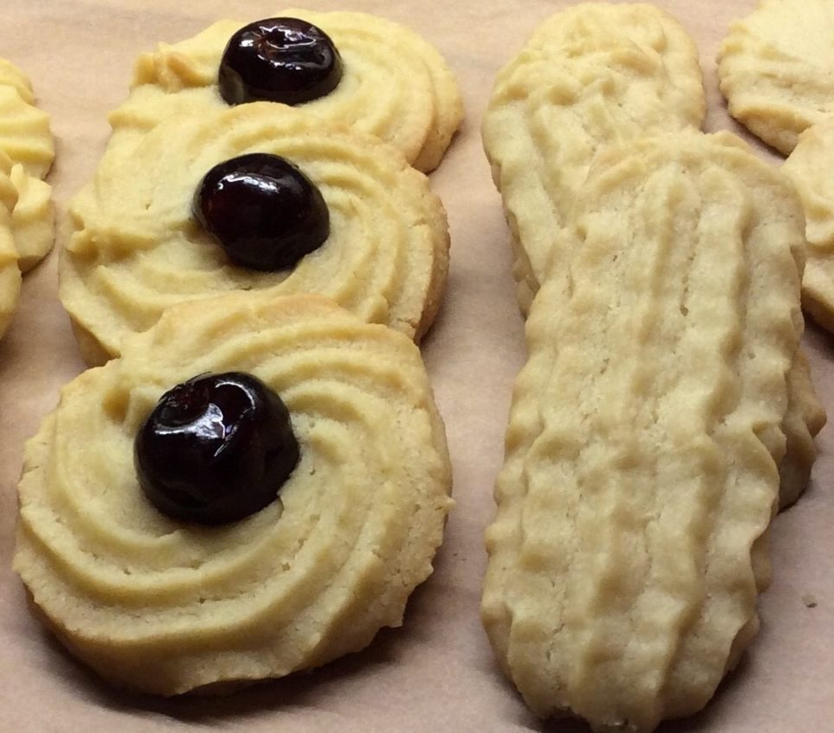
Equipment - Large mixing bowl, fork, wooden spoon, plastic spatula, piping bag and large nozzle, baking tray, palette knife, cooling tray

Method
- Using a fork and wooden spoon cream butter and icing sugar until it is pale and fluffy.
- Add in flour and corn flour and mix with a wooden spoon until mixture is combined.
- Now mix vanilla essence in with the biscuits dough.
- Put a large piping nozzle into a piping bag and add the biscuit mixture
- Pipe the biscuits on the tray they will be baked on and make sure they are spaced sufficiently apart because they do expand.
- Bake the biscuits at 170°C for 15-18 minutes until lightly golden brown. Then place them onto a wire rack to cool to room temperature.

CHEESE STRAWS

Ingredients

185 g Plain flour | 75g Mature cheddar cheese
110g Hard margarine | Pinch of dry mustard (sch)
Pinch of salt (sch) | Pinch of cayenne pepper (opt) (sch)
½ Egg
 | Opt coating/finishing –
 | Sea salt, black pepper, poppy seeds
*Container for taking cheese straws home in/ apron

Equipment – baking tray, mixing bowl, table knife, fork, small bowl, flour dredger, plate, grater, rolling pin, 3mm batons

Method
- Preheat oven at 190ºC, gas mark 5 and lightly flour the baking tray
- Put the flour and salt in to a mixing bowl and add the margarine cut up in to small pieces.
- Rub the fat into the flour until the mixture resembles fine breadcrumbs.
- Stir in the grated cheese, mustard and cayenne pepper.
- Whisk the egg in a bowl and add to the rubbed in mixture. Mix with a table knife to bring the dough together to form a soft but not sticky dough. If the dough is too dry add a little cold water.
- Wrap the dough in cling film and chill it for 30mins.
- Roll out the dough to a square on a floured table to 3mm thick. Cut the square in half and then each half in 1 cm strips.
- Transfer the straws to the floured baking tray
- Bake for 15 – 20 minutes until pale golden brown and crisp.
- Leave the cheese straws to cool on the tray and then they are ready to serve.

FOCACCIA
Ingredients
Mixture
250g Strong white flour
7g sachet dried fast action yeast (sch) can provide on request
130ml warm water
Seasoning – 1tsp salt (sch)
2tbsp olive oil
Olive oil (drizzle on top after cooking opt)
Optional flavours - 1 clove garlic /6-8 olives / sundried tomatoes (opt)
Sprigs of rosemary (opt)
*Container for taking bread home in/ apron
Equipment – large bowl, palette knife, baking tray/cake tin, measuring jug, saucepan, sharp knife, chopping board

Method – Set oven to 220ºC, gas mark 7.
- Place the flour into the bowl, Mix the yeast into one side of the flour, and the fine salt into the other side. Then mix everything together, this initial separation prevents the salt from killing the yeast.
- Make a well in the middle of the flour and add 2 tbsp oil, gradually add your warm water until you have a slightly sticky dough. Continue mixing until you have a smooth dough.
- Knead the dough for 5 minutes until it is soft and elastic on a lightly floured surface.
- Make the dough into a flat round shape and leave to prove for at least 20 minutes. Meanwhile peel and chop the garlic, pick the rosemary leaves and drain the olives if using.
- Spread your topping over the bread, pushing your fingers right down to the bottom of the dough to make little dimples. Place the tray somewhere warm and leave for 10 minutes or until doubled in size.
- Poke the bread all over again with your fingers
- Bake in the hot oven for 20 minutes or until golden and springy.
- Remove from the oven. Drizzle well with olive oil and a sprinkle of sea salt.

PIZZA
Ingredients
Base | Tomato sauce (or ready-made)
170g strong plain flour | small onion
1tsp fast action yeast (sch) can provide on request | 15ml oil (sch)
15ml oil (sch) | 400g tin tomatoes
100ml warm water (sch) | 15ml tomato puree
 | 5ml mixed herbs/oregano (sch)
 | salt/pepper/sugar to taste (sch)
Toppings (select 50g of any 3) | Cheese (select 150g from cheeses below)
ham/pepperoni/bacon | grated cheddar/red Leicester
tuna/prawns/anchovies | firm mozzarella
peppers/onion/mushrooms | soft mozzarella
sweetcorn/pineapple
olives/tomato/basil/chilli flakes

* Pizza tray or container to take pizza home in /Cookery apron
Equipment - pizza tray, mixing bowl, measuring jug, med. pan, wooden spoon, chopping board, veg knife, flour dredger, tablespoon, grater
Method
- Make Tomato sauce - peal & chop onion and fry gently in oil in pan for a few mins. Add tomatoes, puree, herbs and seasoning. Bring to boil, reduce heat and simmer uncovered for 20min until reduced and thick. Blend until smooth if required. (a jar of ready-made sauce or tomato puree can be used instead)
- Prepare toppings as required.
- Set oven to 200°C, gas mark 6.
- Make base - sieve flour and salt in to mixing bowl, stir in yeast and make a well in centre. Mix oil in to hand hot (37°C) water and pour in to the flour well. Stir to a soft but not sticky dough. Knead dough for 5min, shape as required and place on a floured baking tray or pizza tray.
- Assemble pizza - spread base with 3-4 tbsp. tomato sauce, add toppings and finish with cheese.
- Bake for 15- 20 mins until base is firm and cheese has melted and is golden brown.
CINNAMON BUNS
Ingredients
Enriched bread dough | Filling
225g Strong Plain White Flour | 40g Butter
½ Tsp Salt (sch) | 50g Soft Brown Sugar
25g Butter | ¼ Tsp Cinnamon (sch)
2tsp Fast Action Dried Yeast – CAN BE PROVIDED BY SCHOOL ON REQUEST | Glaze (opt)  2tbsp Clear Honey, Apricot Jam Or Water With Sugar Dissolved
100ml Milk (Warmed at school)
1 Egg
*Suitable container for transporting home

Method
- Pre heat oven at 220ºC/gas 7.
- Sieve flour and salt into mixing bowl. Rub in butter and stir in yeast
- Warm the milk and beat the egg and mix together.
- Make a well in the flour and add the liquid and mix to a soft but not sticky dough.
- Knead for 5min and leave in a covered bowl to prove for 10min.
- Knock back dough (knead again) and roll on lightly flour area in to a large rectangle.
- Melt the butter and brush over the dough. Sprinkle with the sugar and spice and trickle over the remaining butter.
- Roll up dough like a swiss roll and cut into 9 equal pieces. Place them close together on a baking tray or in a cake tin.
- Cover with cling film and leave to prove.
- Sprinkle with castor sugar and bake for 15-20min until golden brown.
- Remove from oven and glaze while still hot.

PASTA
(EXTRA)
Ingredients
Pasta
200g of ‘00’ Flour or Strong plain flour
2 Eggs
2tbsp Oil (sch)
* Container to take your pasta home in / apron

Method
- Add 2 eggs, and 2tbsp of oil into the middle of 200g of ‘00’ flour.
- Gently stir a little flour at a time into the egg with a fork.
- Continue to mix together until all flour is combined and turn onto the surface.
- Work the dough together into a ball using your fingers.
- Knead for 5 minutes until smooth, silky and stretchy with the heal of your hand.
- Optional step to wrap with cling film and chill/ rest for 30 minutes (this is time dependant)
- Roll dough to a rectangle then either; continue to roll to reduce the thickness or use a pasta machine is available start at the widest setting and then gradually reduce the thickness.
- Roll up or if your using a pasta machine roll again reducing the roll we thickness each time.
- Cut pasta into narrow strips by either; slicing off the dough or rolling through the pasta machine again.
- Open pasta up and hang to dry for 30 minutes before boiling for 2 minutes in salt water.

Note: Add 60ml of beetroot juice for pink and 60ml of spinach juice for green

SWISS ROLL

Ingredients
Pasta
200g of ‘00’ Flour or Strong plain flour
2 Eggs
2tbsp Oil (sch)
Sponge
75g caster sugar
75g plain flour
3 eggs
5 tablespoons of jam/curd

* Container to take your swiss roll home in / apron
* Swiss roll tin (approx24x33cm) – school provides on the day!

Method

Set oven 200ºC, gas 6, grease and line swiss roll tin.
- Whisk eggs and sugar together in a bowl until the mixture is very thick and leaves a trail from the beaters.
- Fold in the sieved flour very gently using a metal spoon.
- Pour into the prepared tin and place in the oven for approximately 6-10 mins (oven dependant).
- Place a sheet of greaseproof paper onto the work surface and sprinkle lightly with caster sugar.
- Turn the sponge on to the paper and remove the lining paper.
- Beat jam until smooth (if lumpy it can be heated gently in the microwave). Spread with jam/curd and roll up the sponge using the greaseproof paper.
- Sieve icing sugar gently over the top.

SHORTBREAD
(EXTRA)
Ingredients
Biscuit | Decoration (opt)
180g plain flour | 50g icing sugar
55g caster sugar | A few drops of water
125g soft margarine
 | Glace cherries, smarties or similar

*Container to take biscuits home in / cookery apron
Equipment - baking tray, cooling tray, large mixing bowl, table knife, tablespoon, flour dredger, rolling pin, batons, biscuit cutters (small bowl, teaspoon)

Method
- Preheat oven at 190 C, gas 5 and lightly greased the baking tray
- Put the flour, fat and sugar into mixing bowl and rub in the fat until it resembles breadcrumbs
- Using one hand, knead and squeeze the mixture until it becomes like soft pastry – a soft dough.
- Roll dough out on a lightly floured table to 3mm thickness - use batons for even thickness
- Using fancy cutters cut out shapes and put the shapes on to the baking tray. If you want them for hanging as a decoration use a thick skewer to make a hole
- Bake for about 10 - 15mins until pale golden brown
- As soon as it comes out of the oven remark the hole.
- Transfer the shortbread biscuits on to a cooling tray to cool
- Carefully mix water into icing sugar a drop at a time to make a stiff icing. Spread or pipe on to cooled biscuits

